Speed Watch Team
After lengthy discussions we are happy to report that the first Speed Indication Device (SID) has been installed in Hepworth. At the moment it is located at the A143 end of “The Street”, just past “The Maltings” on the right hand side of the road as you are leaving the village.

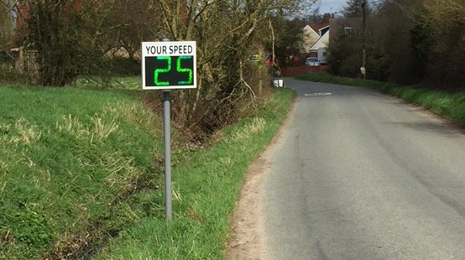

It is monitoring the road traffic coming into the village from the A143 and from the date of installation it has been achieving its purpose. Many vehicles are approaching the radar at more than the speed limit but before leaving its range they are slowing down to 30MPH.
We have located several positions throughout the village and in time the SID will be relocated to each of these.
We wish to thank Borough Councillor Carol Bull for the generous donation of £739 towards the cost of the machine and to the Hepworth Parish Council who contributed the remaining £1700
Three mounting poles were installed, free of charge, by the Highways Department of the Borough Council and many thanks to them.
We would also like to thank a Kathryn and Phil Clifford who generously donated an Android Phone as an operating device to collect the data accumulated by the SID.

